perficient.gif360 DEGREE ASSESSMENT SYSTEM

rEVIEW template CREATING GUIDE

Login 360 Degree Assessment System

Url: <http://10.2.31.11>

Username: admin

Password: password

Create a new webform content

**>>Click *content* button to content configuration page.**

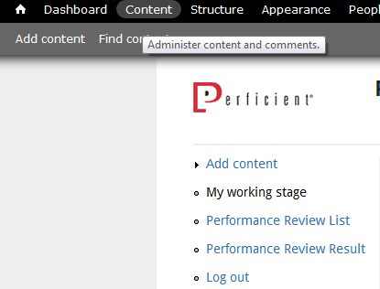

**>>Click *Add content* link.**

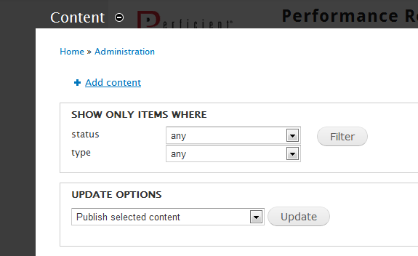

**>>Choose *Webform* Link.**

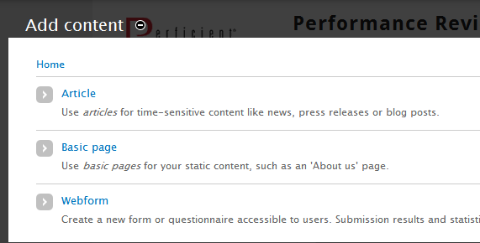

**>>Edit webform title.**

1. You can edit the title for this review, for instance: Perficient China Employee Feedback-Associate Technical consultant template.
2. Keep the body blank.

*Note: 1. The title MUST be “Perficient China Employee Feedback-” +* ***LEVEL****(like: Associate Technical) + “template”.*

*2. Do remember to add* ***template*** *to the end of title.*

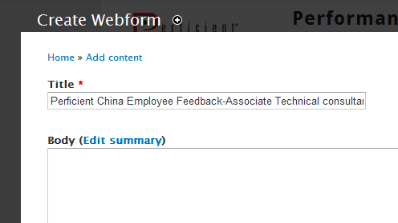

**>>Configure the *Comment settings*.**

Choose ***closed***.

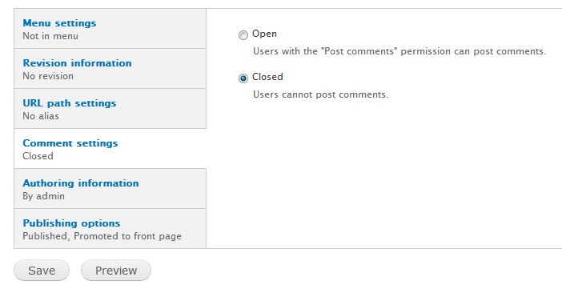

**>>Save this content by click *Save* button.**

Configure webform components

Once you saved the content, the system will direct you to webform components configuration page automatically, if not, please click ***webform*** tab on the top.

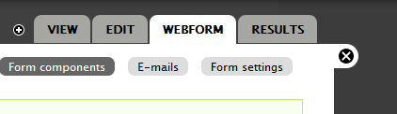

**>> If you want to add a selection question, create an option select component.**

1. Edit the question title in the input text box, for instance: 1. Delivers results against role and task responsibilities.
2. Select ***Select options*** as the type.
3. Tick the checkbox, for the selection question is mandatory.
4. Click ***Add*** button. Once you clicked ***Add***, system will direct you to detail configure page for this component.

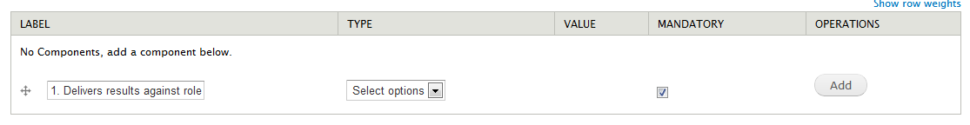

1. In component configure page, you can set the label, field key, score weight…

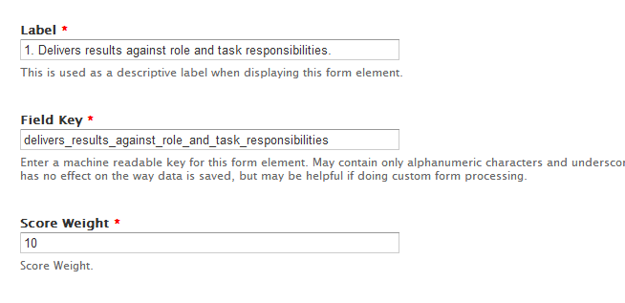

**Label:** the question title.

**Field key:** the unique id for this question in system, it will be created automatically by system.

*Note: Do remember that the field key* ***cannot*** *start with digital number! Please check every time you create it.*

**Score weight:** the score weight for this question.

1. Still in component configure page, you should also set the options.

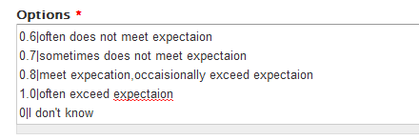

*Note: Key-value pairs MUST be specified as "****value|Some readable option****".*

1. Save the component.

**>>Create Comment for each selection question**

1. Edit the title in the input text box. For a comment component, here should be “Comment”.
2. Select ***Textarea*** as the type.
3. Click ***Add*** button. Once you clicked ***Add***, system will direct you to detail configure page for this component.



1. In component configure page, you can set the label, field key

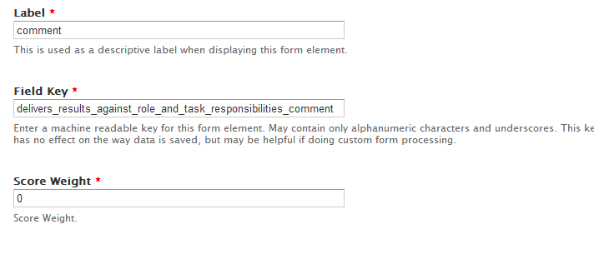

*Note: Do remember that If you create a comment for question A, the field key MUST be question A’s field key + “_comment”.*

1. Save the component.

**>>Create page break component.**

1. Edit the title in the input text box.
2. Select ***page break*** as the type.
3. Click ***Add*** button. Once you clicked ***Add***, system will direct you to detail configure page for this component.
4. Just save the component.



**>>Create strength/development area component.**

1. Edit the title in the input text box. For instance: Strenghts (at least 3).
2. Select ***Fieldset*** as the type.
3. Click ***Add*** button. Once you clicked ***Add***, system will direct you to detail configure page for this component.



1. Tick on the Collapsible.

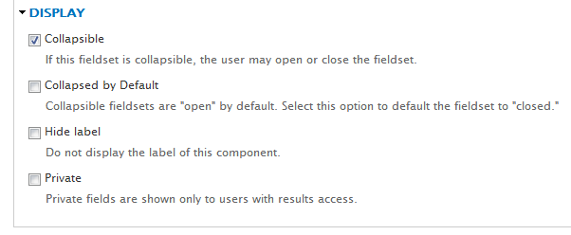

1. Save the component.
2. Add another component, select ***Textfield*** as the type.
3. If the component is mandatory, tick on the mandatory checkbox.



1. Click ***Add*** button. Once you clicked ***Add***, system will direct you to detail configure page for this component.
2. Save the component.
3. Drag the “strength one” below the “Strenghts (at least 3)”.



1. Save the webform setting.

